Games Development Pipeline – Rube Goldberg Machine Report

Description of Machine Design and Features

The rube goldberg machine I had designed would follow a series of events which would eventually lead up to a ball falling into a box some of the events that would lead up to this were balls rolling down various ramps , dominos falling and triggering other events such as knocking a cylinder off of a shelf which could then be used as a weight to land on a seesaw and catapult another object to start another set of collisions to carry on the machine another feature I wanted to add to my design was to have multiple things happening at once to make my machine more complex the final events would lead up to a set of dominos which would eventually fall on a seesaw so the other side would be raised to make a ramp allowing a ball to roll down it and fall in the final bucket

Description of Events and Sequencing

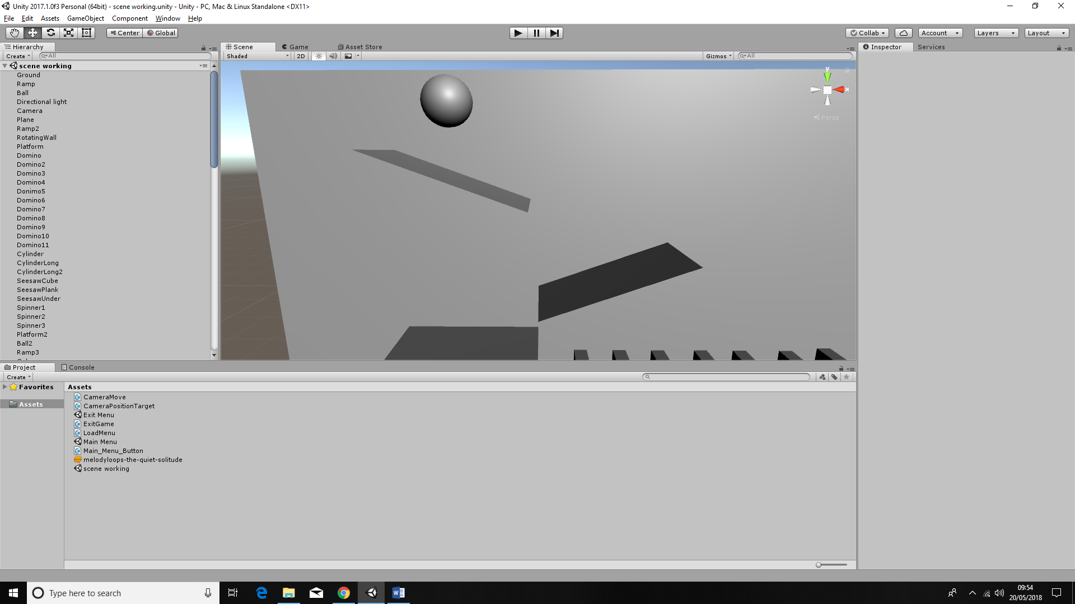When the machine starts off the user will be faced with a menu screen with a button to start the sequence when the button is pressed a ball will begin to fall until it hits a short ramp which leads to a smaller ramp below

**Figure 1 – Device 1 (starts as the ball falls when the game starts)**

when the ball hits the wall the wall will start to spin leading the ball off of the stage

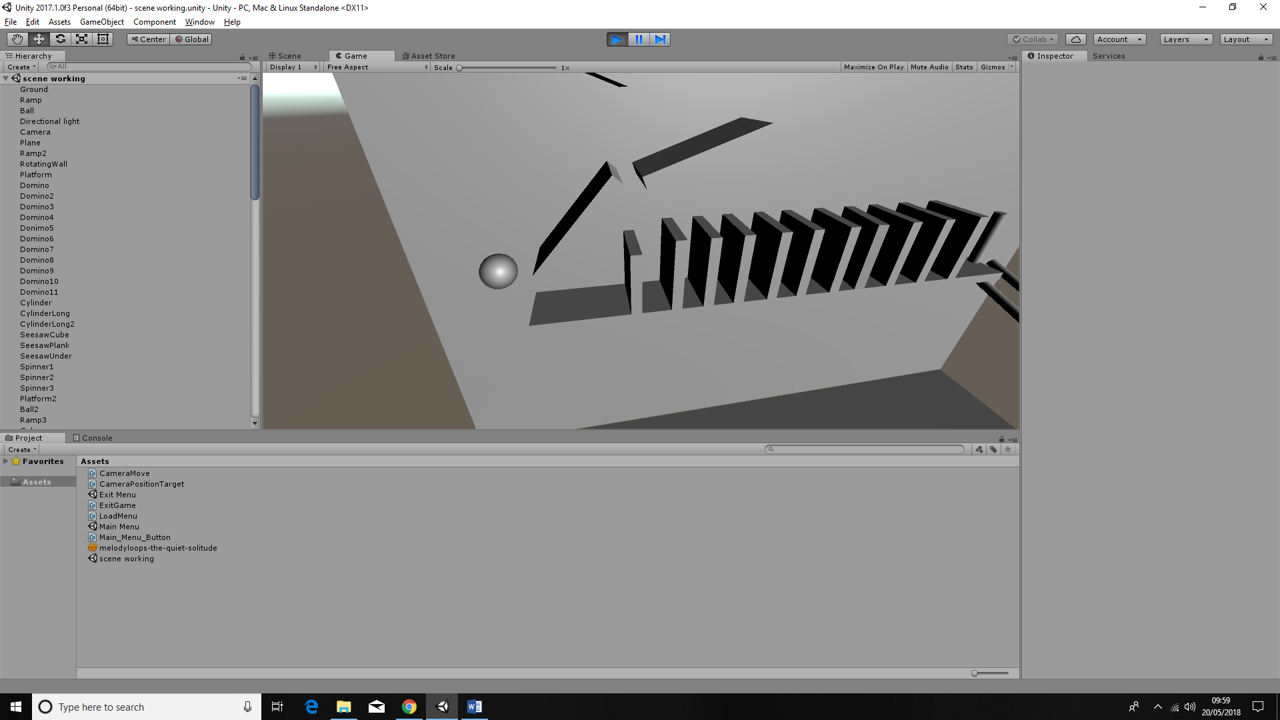**Figure 2 – Device 2 (Starts when the ball collides with the platform)**

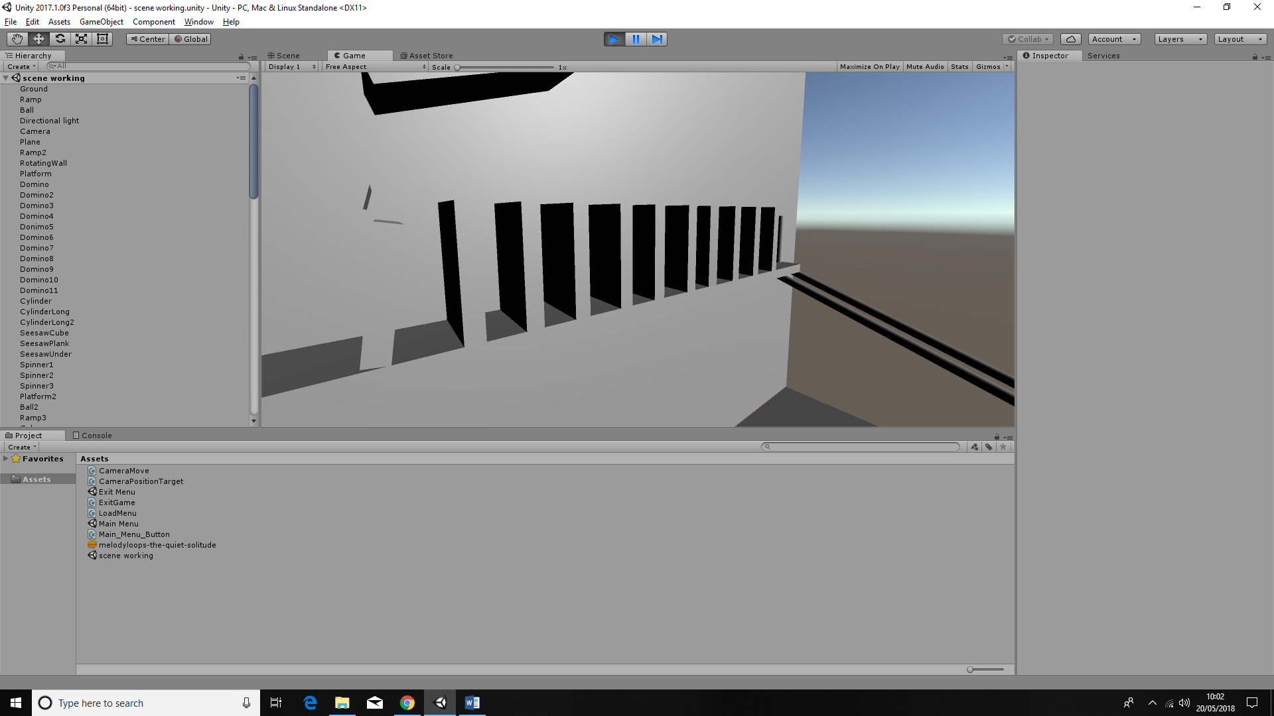

**Figure 3 - Device 3 (starts when the spinning platform collides with the first domino)**

and as it does this it collides with the first domino on a shelf below which will then continue along the shelf slowly knocking over around ten dominos at the end of the shelf the last domino will collide with a cylinder knocking it on to two rails which the cylinder will then roll down these rails until falling off the other end

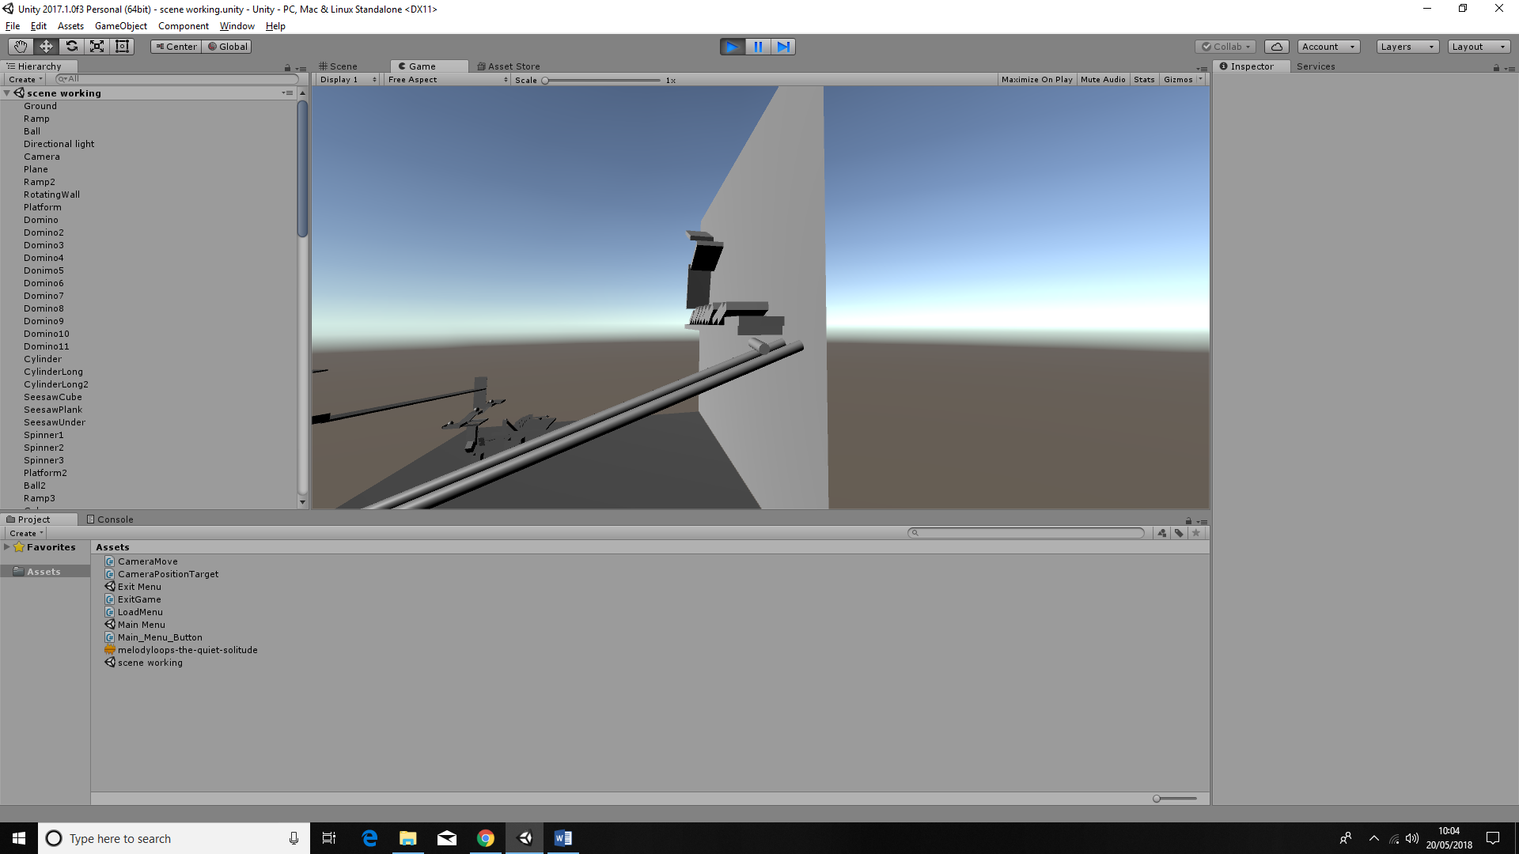

**Figure 4 – Device 4 (Starts when Final domino Collides with Cylinder)**

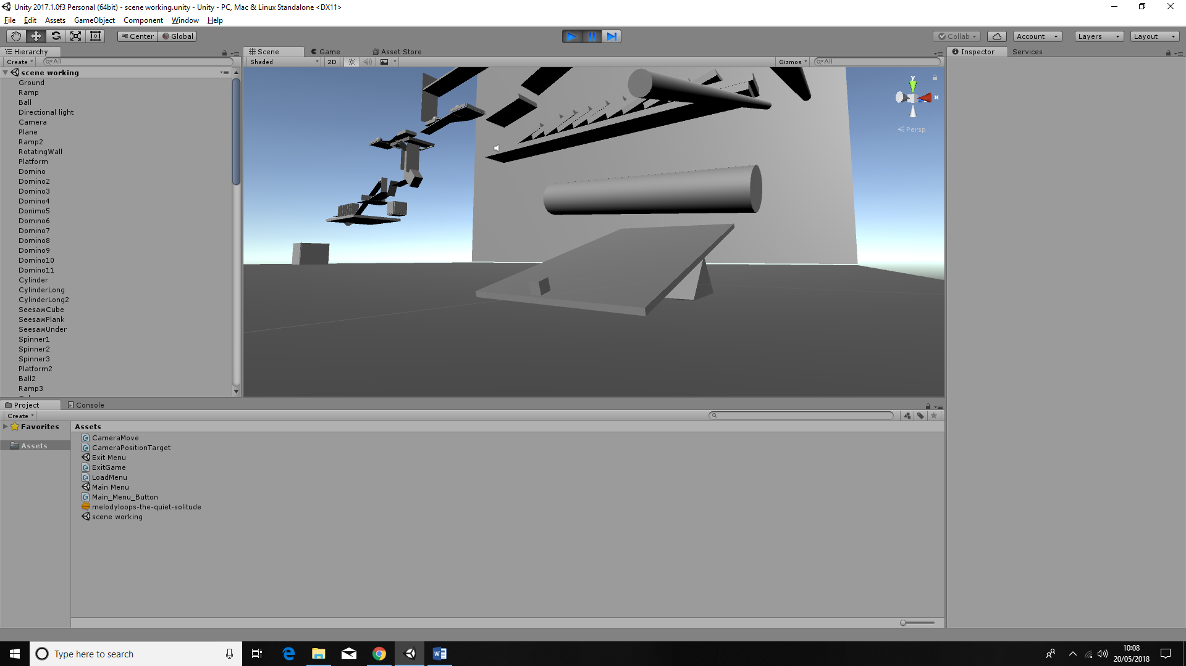 it will then fall to the ground and hit the elevated side of a seesaw which will then catapult a small cube weight up into the air

**Figure 5 – Device 5 (Starts when cylinder lands on the other end of the seesaw)**

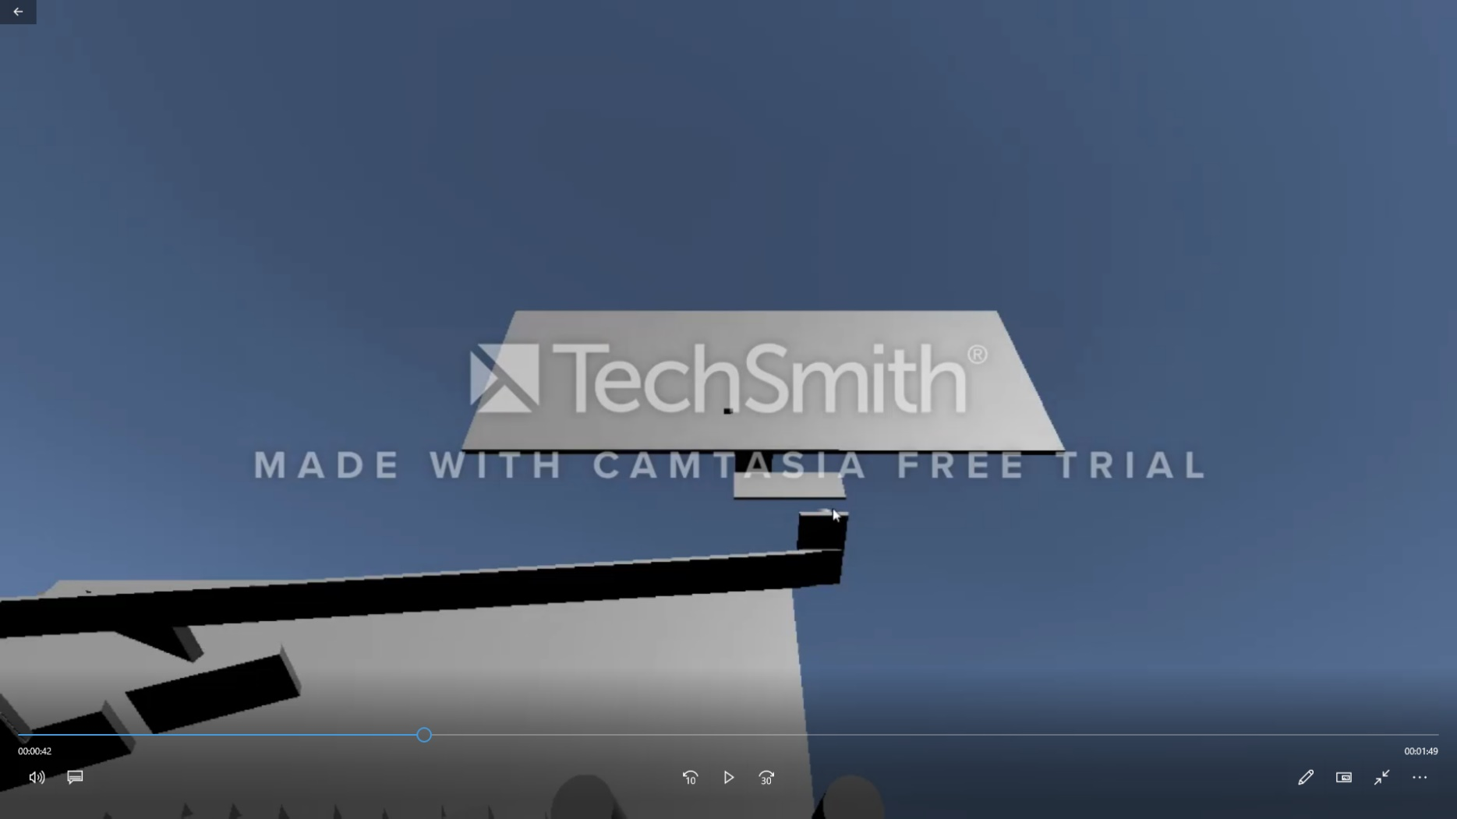 where it collides with bottom of a large board which will then cause it to spin and hit another smaller spinning board which spins vertically to hit a horizontal spinning board

**Figure 6 – Device 6 (Starts when the cube from the seesaw collides with the bottom of the board)**

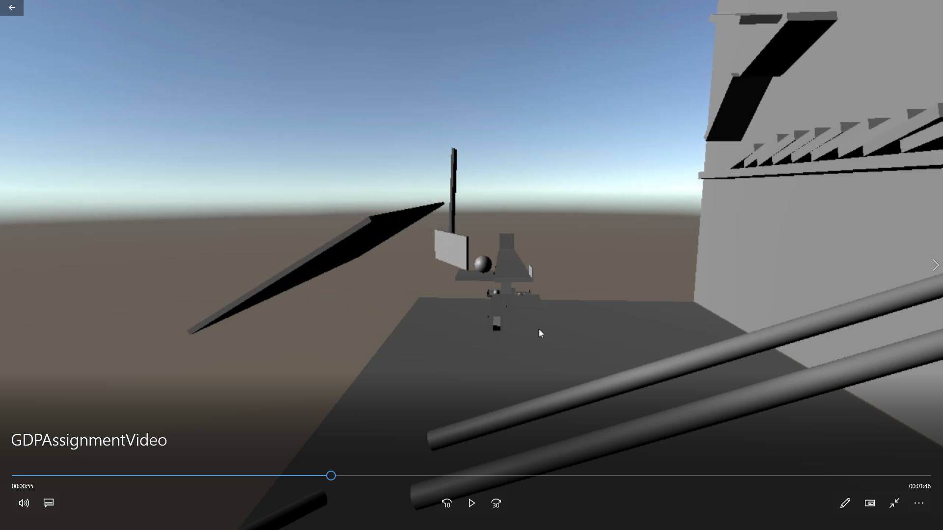which then knocks a ball onto a long ramp

**Figure 7 – Device 7 (Starts when spinning board hits the ball)**

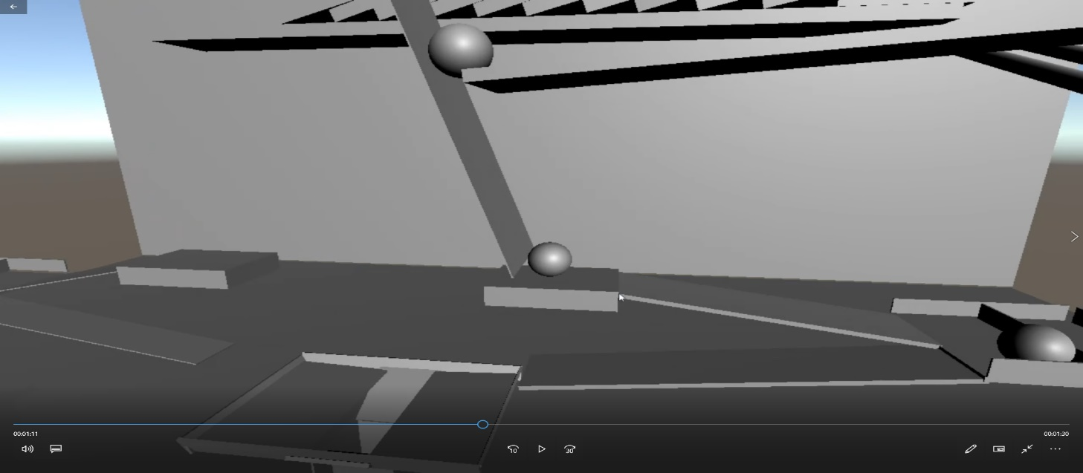 at the bottom of this ramp the ball will collide with a small board making it spin and it holds the ball in place while it rotates it hits another ball sending it down a ramp

**Figure 8 - Device 8 (Starts when the board hits the ball underneath)**

to collide with a small barrier to knock a ball into a funnel and down a pipe

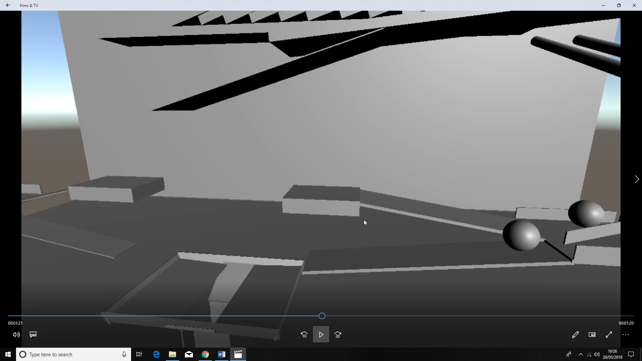

**Figure 9 – Device 9 (Starts when the ball rolls down the ramp)**

when it rolls out of the pipe will hit a platform causing it to spin and the ball will fall into a box

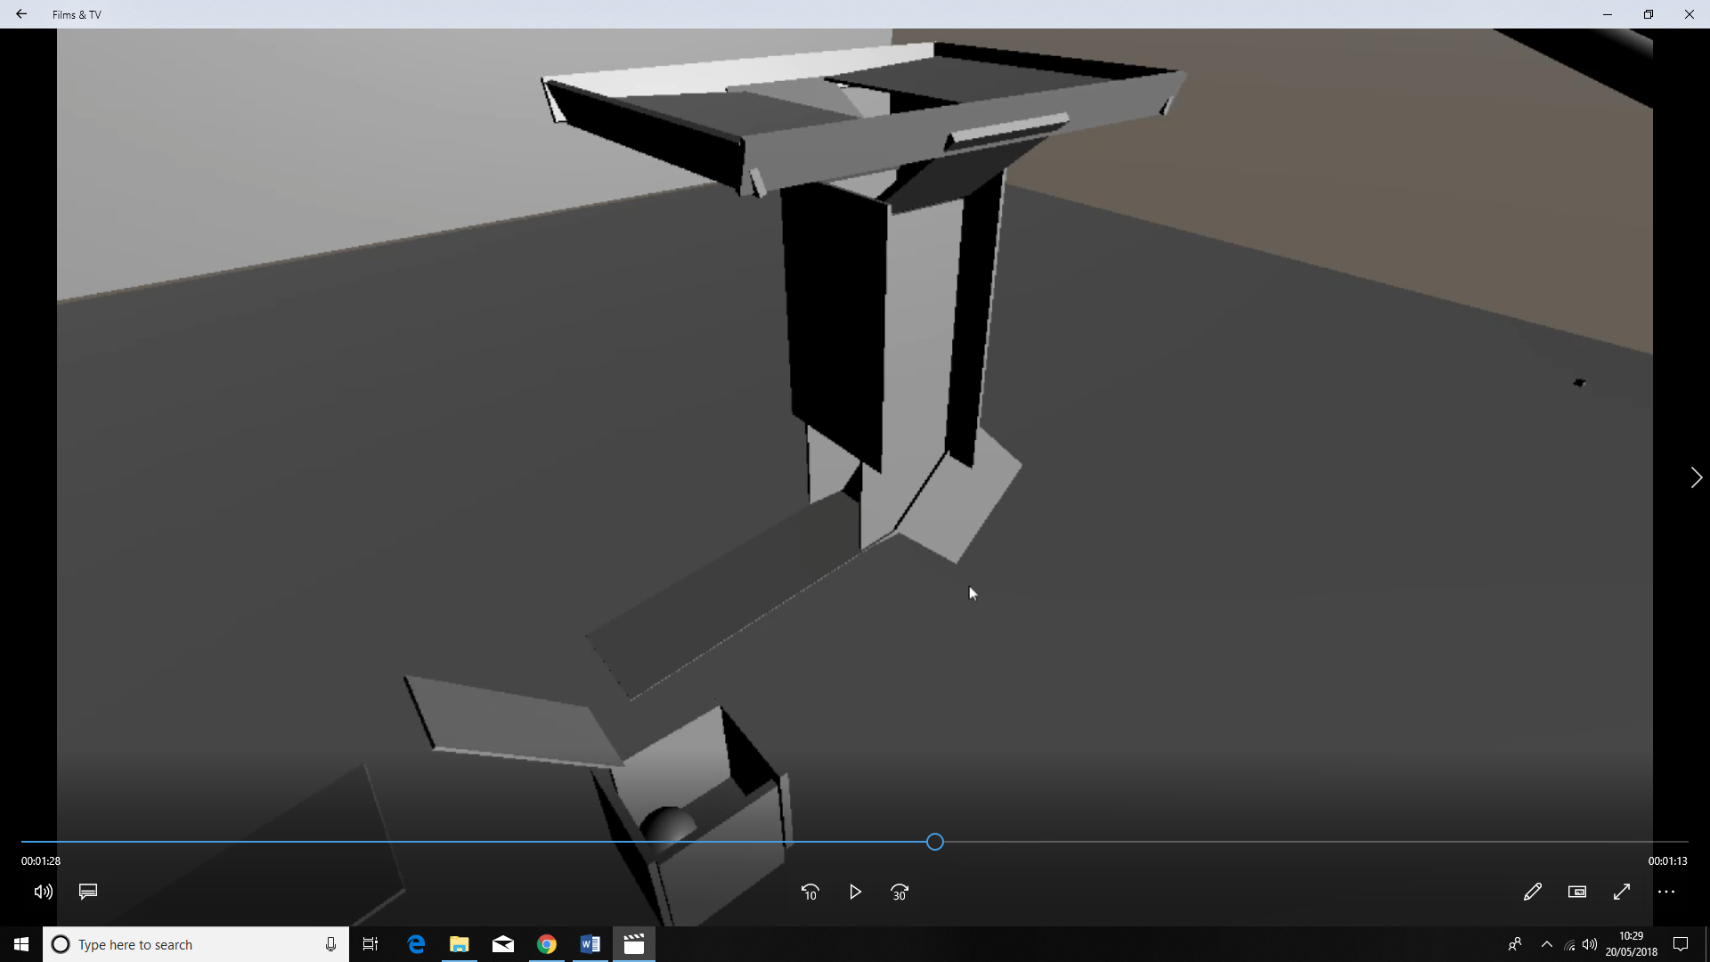

**Figure 10 – Device 10 (Starts when the ball collides with the platform)**

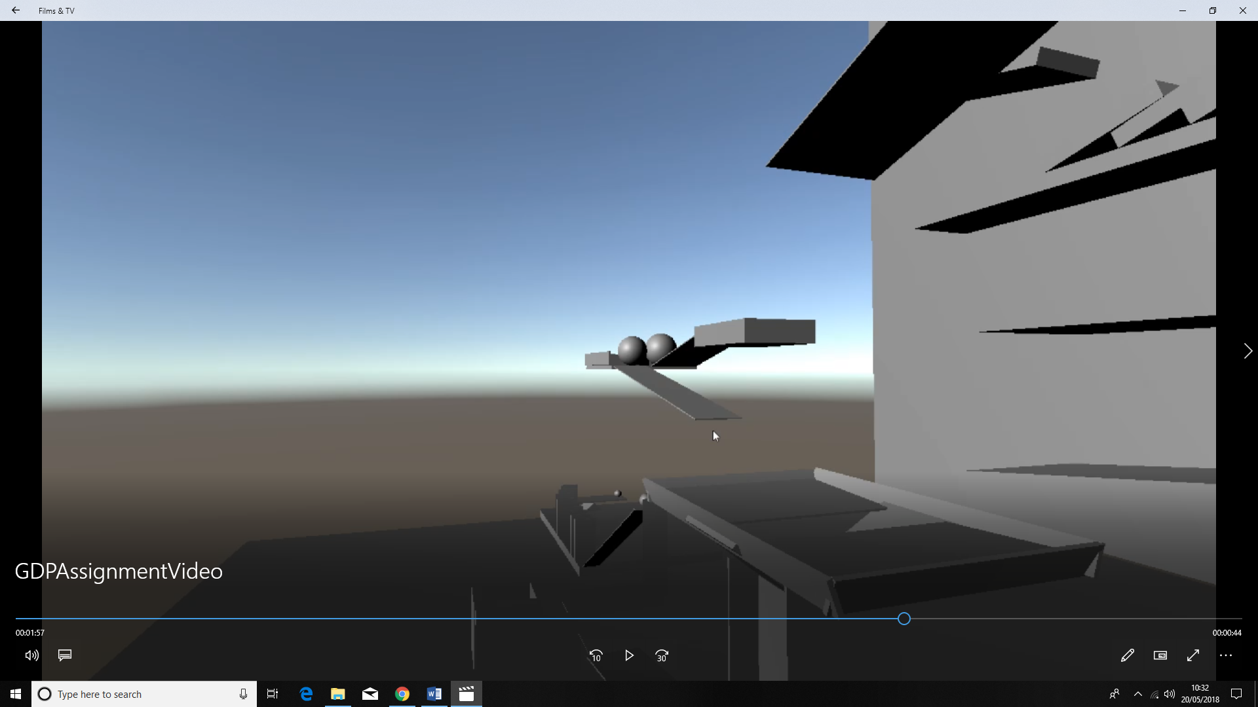 while all this happens the platform that held the first ball in place will continue to spin until it becomes a ramp for the first ball which then rolls down to hit another barrier making a ball slowly roll forwards until falling in to the funnel

**Figure 11 – Device 11 (Starts when the ball is pushed by the barrier)**

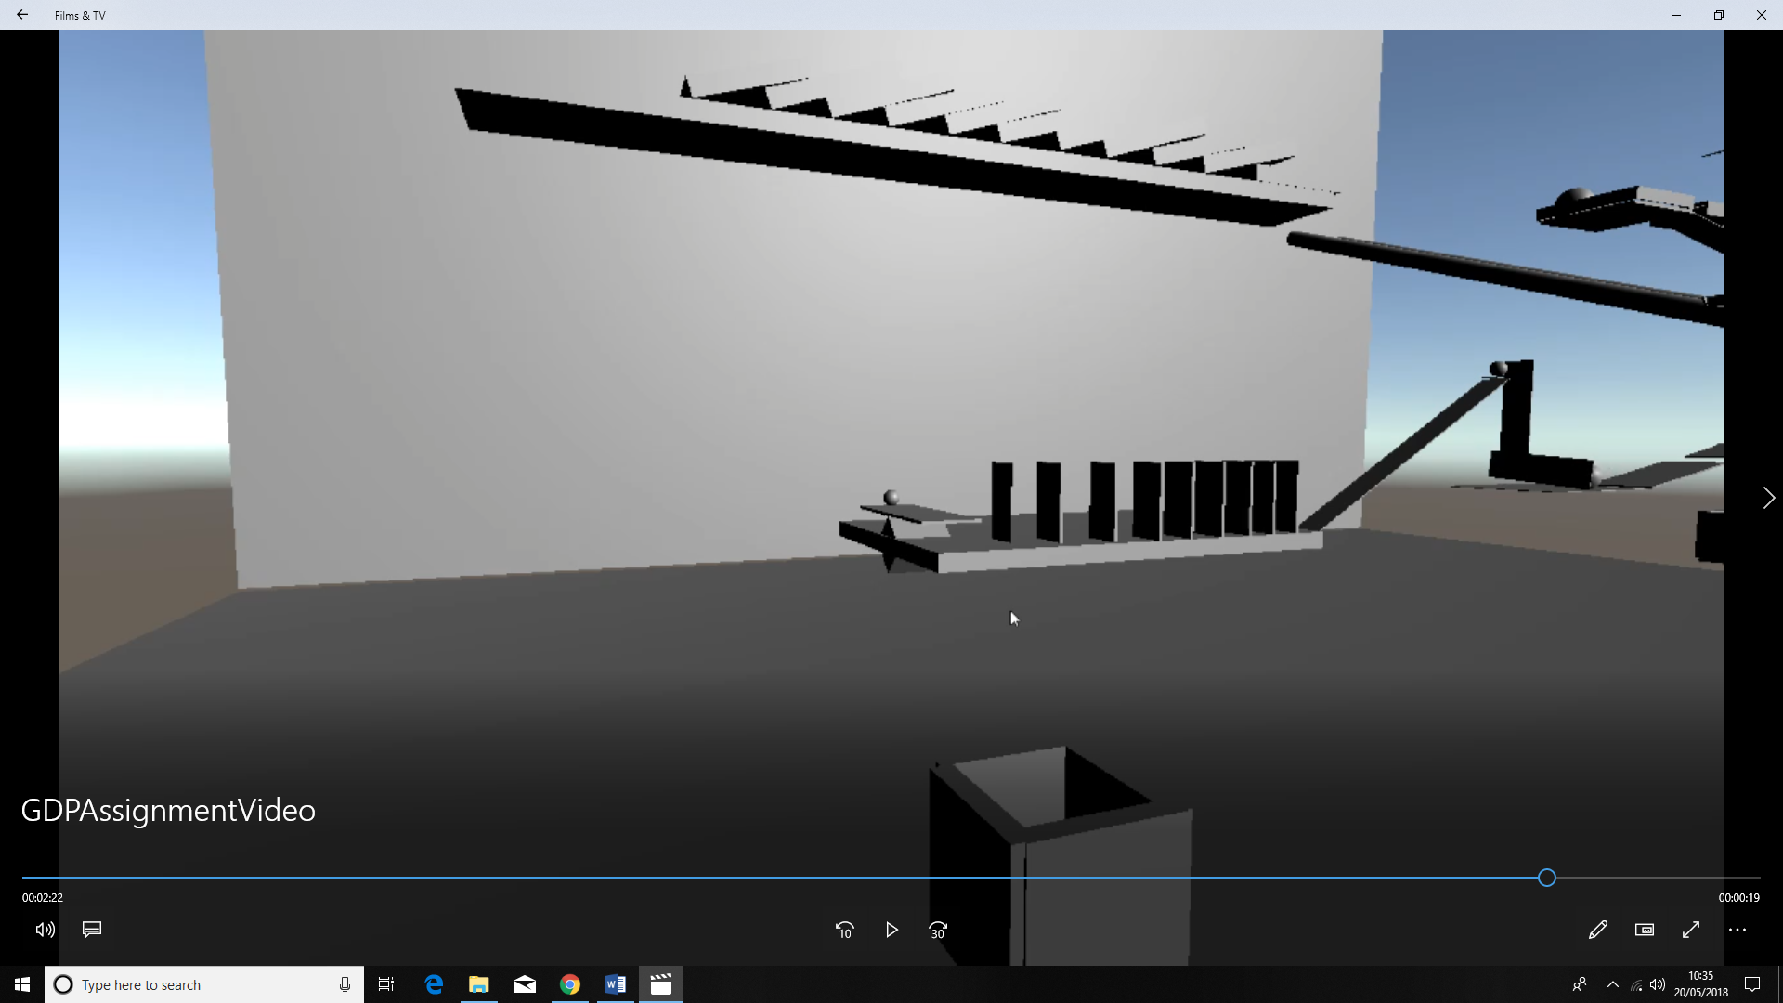when this ball hits the bottom of the pipe it the platform will have spun all the way round allowing this ball to roll on top of it and cross the gap and fall on to ramp and roll into another barrier that will start to spin until it hits a vertical which also spins

**Figure 12 – Device 12 (Starts when the ball hits the board)**

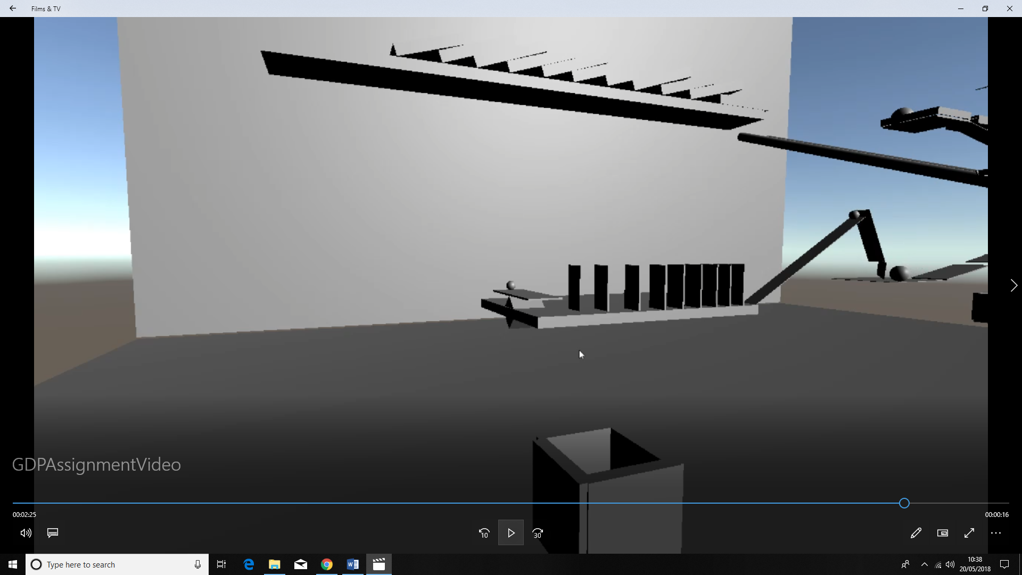 and knocks a ball on to a ramp causing in to collide with a domino at the bottom of the ramp

**Figure 13 – Device 13 (Starts when the board hits the ball onto the ramp)**

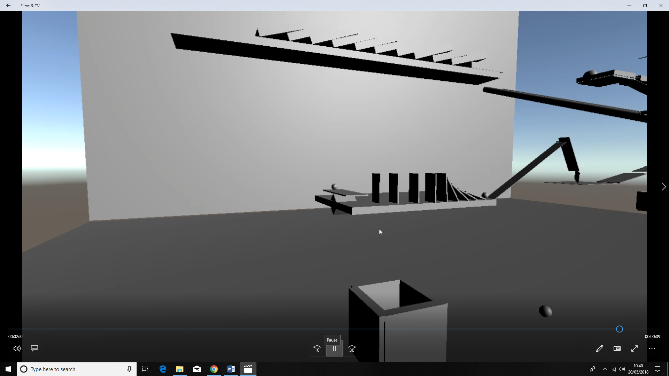this starts another set of dominos to fall onto each other

**Figure 14 – Device 14 (Starts when the ball hits the first domino)**

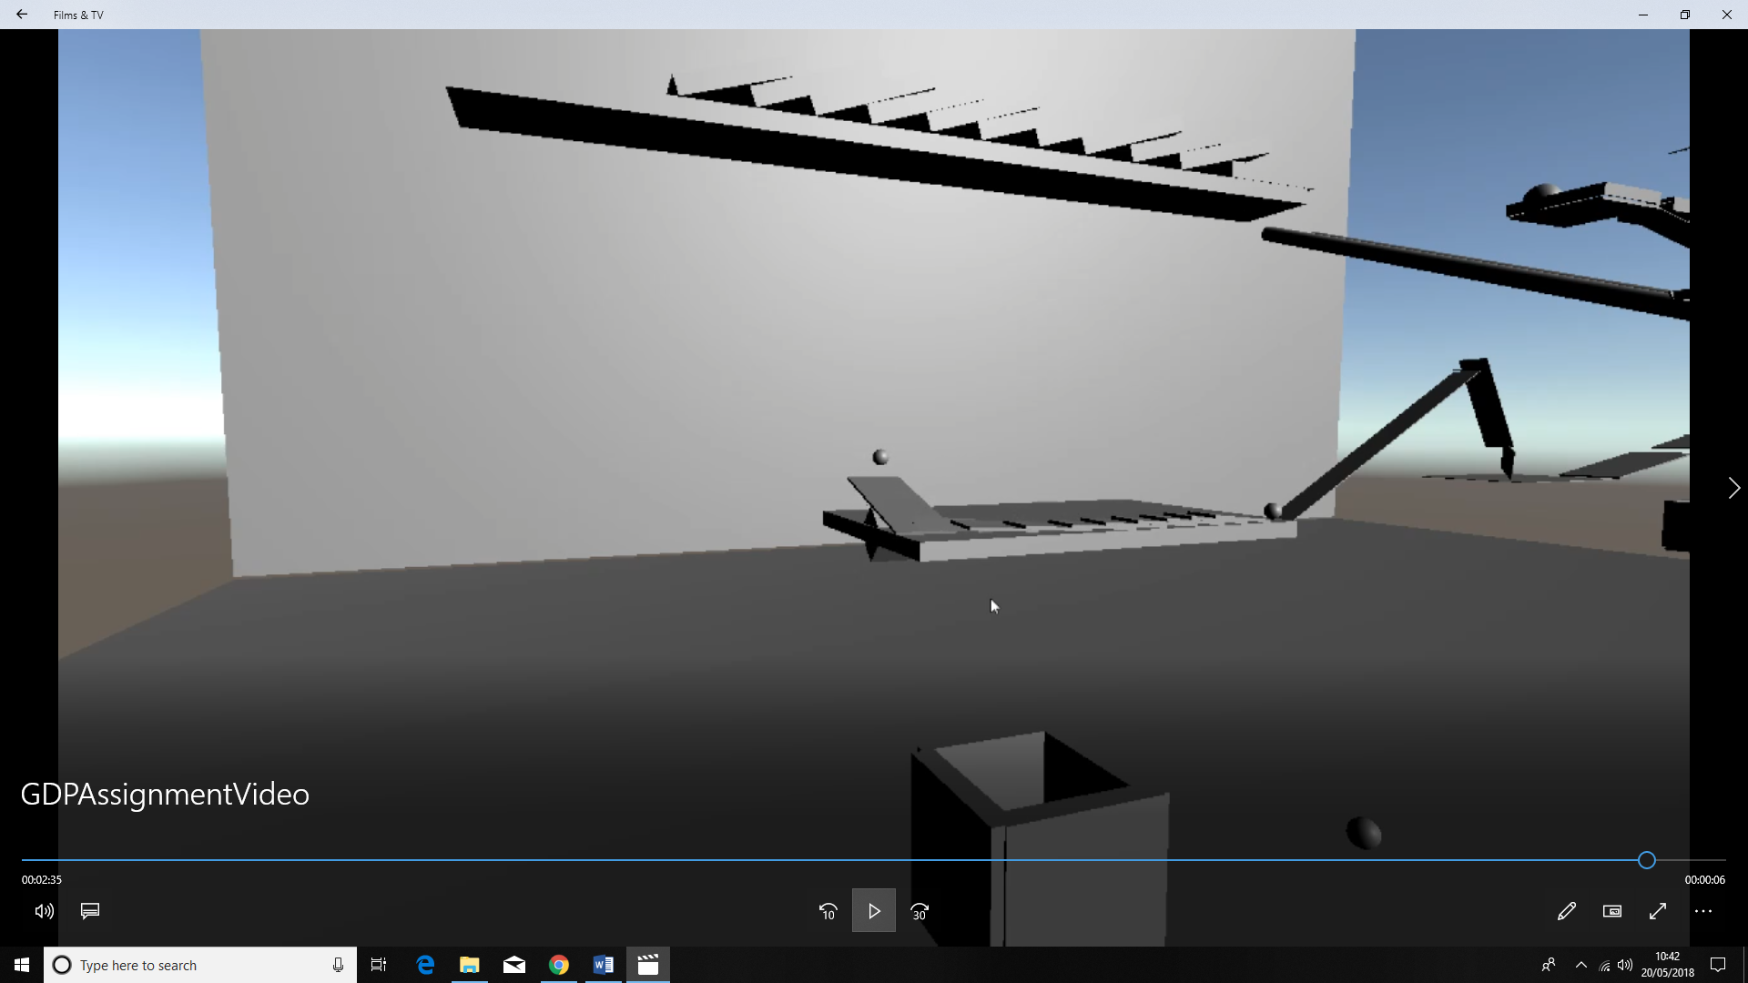 until the last one falls on a small seesaw with a small ball on the other end making it slide along the seesaw and falling of the end into the box to finish the machine.

**Figure 15 – Device 15 (Starts when the domino falls onto the seesaw)**

Discussions of Difficulties Encountered and Solutions

While making my machine I ran into several issues while making my machine I ran into several issue mostly due to unity‘s physics being inconsistent as once I added the seesaw on the ground that would launch the small weight every time I would test my machine the small weight would be launched to different heights the solution I had to use to solve this issue was make the board that I wanted the weight to hit much larger making the weight more likely to hit it although there are still some occasions when the weight will still be launched much higher.

Another issue I had as most of my machine relied on physics I had to get the mass right on all the objects in the scene so that they would interact in the right way the real issue I had with this was in the section where balls go down two different paths as the second had to go down at the right time to cross the gap to solve this I made the second ball heavier so it would take longer to push it on to the ramp but I also had to make sure that it could still cross the gap as if it was too heavy the platform would spin back to fast making the second ball fall in the same box as the first another example of this would be with the catapult at first I made the weight on the catapult light to launch it higher but then it would have a very small effect on the board in the air so I had to make the cylinder a lot heavier to launch it higher which meant I had to change the mass of the domino so that they were able to knock the cylinder off of the shelf

**References**

Unity, 2018. *Unity Documentation Scripting API Application.Quit* [Online]. Available From: <https://docs.unity3d.com/ScriptReference/Application.Quit.html> [Accessed 20th May 2018].

Unity, 2018. *Unity Documentation Scripting API SceneManager.LoadScene* [Online]. Available From: <https://docs.unity3d.com/ScriptReference/SceneManagement.SceneManager.LoadScene.html> [Accessed 20th May 2018].

Brightspace, 2018. *Games Development Pipeline AutomaticCamera-V2* [Online]. Available From: <https://brightspace.bournemouth.ac.uk/d2l/le/content/10392/viewContent/97077/View> [Accessed 20th May 2018].